[](http://www.nugardt.com)NuGardt SC2Ranks.com Custom Division Profiler

Author: Kevin ‘OomJan’ Gardthausen ([kevin@nugardt.com](mailto:kevin@nugardt.com))  
Last Update: 2013-07-05  
Home: <http://www.nugardt.com/software/sc2-cdp/>  
Blog: <http://www.teamliquid.net/blogs/viewblog.php?id=254063>

[](http://www.sc2ranks.com)The NuGardt SC2Ranks Custom Division Profiler lets you download Ranking Statistics for a Custom Division on [sc2ranks.com](http://www.sc2ranks.com) to the web format (HTML). By default the Handle with Care ([HwC]) Division (Division ID 7085) is loaded (my clan :P).

You can specify a Custom Division by either typing the ID into the text field or paste the custom division URL from <http://www.sc2ranks.com/custom>.

Create your custom division on [sc2ranks.com](http://www.sc2ranks.com) by going here <http://www.sc2ranks.com/custom_create>. Then add players to that custom division. Every player needs to be placed in 1v1 division (in game) to be shown in the custom division.

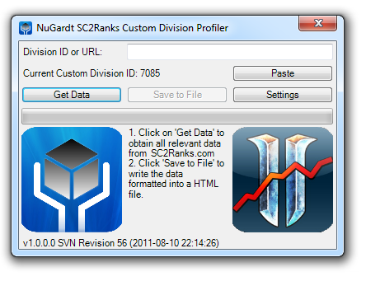

# Command Line Switches

* /config=*FILEPATH*
  + The path to the config file. Other command line flags override the config.
* /customdivisionid=*7085* OR /cid=*7085*
  + Set the custom division. Default: 7085
* /commandline OR /cl
  + Starts the app in command line mode.
* /refresh OR /r
  + Refreshes the players in the custom division.
* /autodownload OR /ad
  + Automatically start the download the when the program starts.
* /autoclose OR /ac
  + Automatically close the program after a download has automatically started (/autodownload).
* 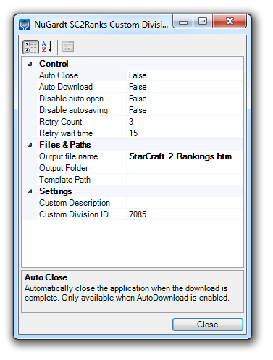/disableautosave OR /das
  + When specified does not automatically save the data to file.
* /filename=*FILENAME*
  + Specify output file name. Default: StarCraft 2 Rankings.htm
* /savepath=*DIRECTORYPATH*
  + Specify save path. Default: Program working directory
* /template
  + Specify a template for writing data. Values:
    - *$achievement$* 
      * Achievement Points Ranking Table
    - *$1v1$*
      * 1v1 Ranking Table
    - $2v2$
      * 2v2 Ranking Table
    - *$3v3$*
      * 3v3 Ranking Table
    - *$4v4$*
      * 4v4 Ranking Table
    - $timestamp$
      * Timestamp when the file was generated (Format: yyyy-MM-dd HH:mm:ss.fff)
    - $version$
      * Version used (Format: v*Major*.*Minor*.*Build* [SVN Revision *Revision*])
    - $generatedby$
      * User who generated the file (Format: Computer\Username)
    - $generatedin$
      * The time in seconds it took to retrieve all data and generate the file
    - $customdescription$
      * As specified in custom description.
* /verbose OR /v
  + Provides more details in error messages.
* /retrycount=3
  + The number of retries per data request to SC2Ranks.com before giving up. Default: 3 (Valid Range: 0-5)
* /retrywaittime=*15*
  + The number of seconds to wait between retries. Default: 15 (Valid Range: 0 -180)
* /reset
  + Sets all saved setting back to application default.

# Requirements

* Windows 8; Windows 7; Windows Server 2008; Windows Server 2003; Windows Vista; Windows XP or UNIX with mono.
* .Net Framework 4 (<http://www.microsoft.com/net/download.aspx>) or Mono Framework (<http://mono-project.com>) (Tested with v2.10.8.1 and v3.0.11)
* Internet Connection

# UNIX Cronjob Setup

Included in the setup are two shell scripts called ‘nscdp_run_cron.sh’ and ‘nscdp_refresh.sh’. Find these in the “\Tools\Linux” folder. These scripts must be amended to reflect you path on Linux.

# License

[Creative Commons License](http://creativecommons.org/licenses/by-nc/3.0/)  
NuGardt SC2Ranks.com Custom Division Profiler by [Kevin Gardthausen](http://www.nugardt.com/software/sc2-cdp/) is licensed under a [Creative Commons Attribution-NonCommercial 3.0 Unported License](http://creativecommons.org/licenses/by-nc/3.0/).

License: <http://creativecommons.org/licenses/by-nc/3.0/>

Do not use this program to automate mass download statistics. **Fair use** to [www.sc2ranks.com](http://www.sc2ranks.com).

# Support

* Home Page: <http://www.nugardt.com/software/sc2-cdp/>
* E-mail: [kevin@nugardt.com](mailto:kevin@nugardt.com)
* Twitter: <https://www.twitter.com/NuGardt>
* Facebook: <https://www.facebook.com/NuGardt>
* SC2Ranks: <http://www.sc2ranks.com>

# Credits

* [www.sc2ranks.com](http://www.sc2ranks.com) for Ranking Collection and API access
* Kralizek for SC2Ranks API (<http://sc2ranksnet.codeplex.com/>) (Ported to VB.Net and updated)
* Blizzard for StarCraft II and Battle.net

# Change log

* V1.2013.7.5 (2013-07-05)
  + Open Source release.
* V1.3.0.157 (2013-06-30)
  + Maintenance release.
* V1.3.0.122 (2013-05-31)
  + Fixed an exception that could occur when refreshing characters under the Mono framework.
  + Fixed a typo in the settings description for Win/Loss ratio.
  + Added settings for ignoring local cache if desired. Not recommended though.
  + Added command line shortened switches.
  + Added settings for cache duration.
  + Fixed problem where the cache was not saved when an error (403 Fobidden/Too many requests) occurred.
  + Added setting for display custom division rank.
  + Added setting to hide the “Last update”, “Region Rank” and “World Rank”, “Region (R.)” column.
* V1.3.0.94 (2013-05-14)
  + Queries are now cached as specified by SC2Ranks.
  + Added race icons.
  + League icons are now in one image and chosen via CSS.
  + Added more CSS tags to output.
* V1.2.0.55 (2013-05-08)
  + Added support for clan tag in API.
  + Cleaner HTML output.
  + More CSS classes. Refer to the “Base Template.htm” in \Tools
* V1.2.0.53 (2013-05-02)
  + Added support for expansions.
  + The timestamp for teams no longer shows the update timestamp for the character.
* V1.2.0.29 (2013-03-07)
  + Fixed parsing error where character code could be Nothing.
* V1.2.0.18 (2012-08-04)
  + Added option to link all players to SC2Ranks.com URL.
* V1.1.0.14 (2012-04-13)
  + Working under Linux with mono. Tested with Ubuntu 10.04/12.04 LTS with mono (<http://badgerports.org/> for 10.04 backport)  
    Read the Linux section above to details on how to setup a cronjob.
* V1.0.0.10 (2012-03-18)
  + Added command line mode (/commandline)
  + Added option to hide certain columns (last update, losses and win/loss ratio).
* V1.0.0.x (2011-08-30)
  + Code optimized.
* V1.0.0.x (2011-08-24)
  + Fixed problem where settings where not saved.
* V1.0.0.x (2011-08-23)
  + Refreshing the profiles of an entire custom division is now supported.
* V1.0.0.x (2011-08-18)
  + When /autoclose is specified, the output file is no longer opened automatically.
  + Code optimized.
  + Base Template (Base Template.htm) is now included. To use it, specify your template with ‘/template=”BaseTemplate.htm”’ You can edit the file by opening it in a HTML editor.
* V1.0.0.x (2011-08-13)
  + Fixed a typo.
  + Fixed a sorting issue when the world and region rank is not available to a team that has no points.
* V1.0.0.x (2011-08-12)
  + Initial release.